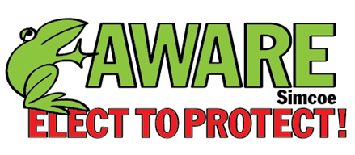
www.aware-simcoe.ca

2014 Municipal Election Candidate Questionnaire

This questionnaire has been compiled by AWARE Simcoe with input from twelve other like-minded NGOs.

AWARE Simcoe considers the preservation of farmland, the protection of water quality and natural heritage and providing transparency in government decision making to be the primary issues of this election. Our goal is to elect representatives who support those objectives.

Question 1

If elected, will you undertake to make decisions consistent with the protection of food producing farmland (classes 1 – 4) and source water regions?

Answer: Yes X No

_________________________________________________________________________________________________________________________

Question 2

Will you sign/have you signed the Food and Water First Pledge? http://foodandwaterfirst.com/pledge/

Answer: Yes X No

Question 3

Are you prepared to make Natural Heritage preservation in Simcoe County a priority?

Answer: Yes X No

Question 4
If elected, will you:

- Hold closed meetings only when absolutely necessary.
Answer: Yes X No

b) Will you support video recording council meetings, including County Council?
Answer: Yes X No

c) Seek public input for any new development proposals within your municipality?
Answer: Yes X No

- Support the use of the Provincial Ombudsman to investigate in-camera meeting violations?
Answer: Yes X No

Question 5

If elected, will you undertake to only support new private development proposals that have had a cost/benefit analysis (including impact on urban sprawl and municipal taxes) done by the municipality and paid for by the developer.

Answer: Yes X No

Question 6

If elected, will you support the creation of a lobby registry for local and County government?

Answer: Yes X No X

I think that could make sense at the upper tier but I don’t think it is feasible at the local level.

Question 7

a) Does your campaign accept corporate or union donations?

Answer: Yes No X

COMMENTS: Please contact me if you have any other questions. 705-434-4481
Thanks Bob Meadow.

Candidate Name: Municipality Date:

Larry Culham Clearview Sept. 23, 2014

Please return the completed questionnaire to the sender as soon as possible, but not later than September 19, 2014. The results will be posted on the AWARE Simcoe website.

N.B.: My survey was received Sept. 20 (after deadline for responses) and it was a Microsoft Works document that is difficult to open/read.

Thank you for completing the AWARE Simcoe Candidate Questionnaire.

